Dear members of London City Council,

We have created a report that provides an extensive overview of traffic in a specific city area. We will provide important details about our model, list all relevant assumptions, and present our analysis below.

We have researched the existing strategies utilized by the traffic light systems in London. We have found out that "most of London’s traffic lights have been managed using technology which uses magnetic detectors buried in the road to detect passing motor vehicles, optimizing timings based on these” (Intelligent Transport, n.d.). Additionally, we have come across Transport for London (TfL) management testing Real-Time Optimizer (RTO) systems, which should take a wider variety of data sources and traffic participants (not just vehicles but pedestrians, cyclists, etc.) into consideration (Intelligent Transport, n.d.). This should provide additional insights into the development of optimal strategies that could manage the duration of traffic lights depending on the time of the day and the traffic flow.

In this report, we would like to narrow the scope of the problem down by applying two traffic light strategies and their impact on the maximum and average traffic flow for vehicles. We have developed a traffic simulation that explores car traffic in the district of Marylebone in London (see Fig. 1). All streets on the map represent one-way roads with arrows indicating the direction of traffic. We have noticed four pairs of traffic lights at the intersections of Upper Wimpole St. and Weymouth St. (top left), Upper Wimpole St. and New Cavendish St. (bottom left), Harley St. and Weymouth St. (top right), Harley St. and New Cavendish St. (bottom right).

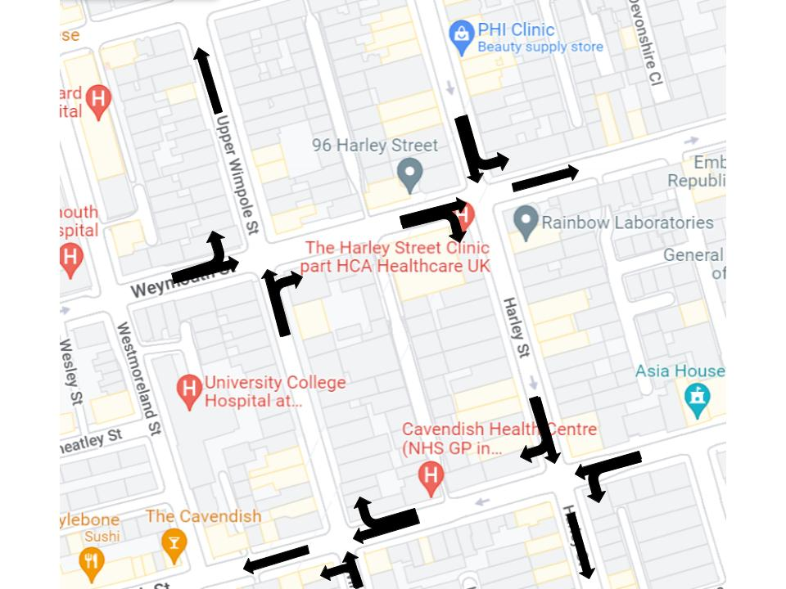

*Fig. 1*. Area in London shown in the simulation. Arrows represented possible directions of the traffic.

We can notice that there is a possibility of turning right and left at the intersections, however, one never has an opportunity to turn both ways from the same street. This results in an easier model implementation that can be improved later in terms of complexity.

Many factors can directly or indirectly influence the traffic flow. In this simulation, we varied car density and traffic light duration to see how they impact average and maximum traffic flow on the selected roads. We believe that the second parameter could help the city optimize the performance of existing traffic lights and minimize the number of traffic jams.

**Model Assumptions and Design**

We have visited Marylebone several times during different parts of the day to measure the number of cars driving along the identified streets. The results regarding traffic density significantly varied, so we came up with a set of general rules and assumptions that we incorporated into the model design:

* Car density remains the same throughout the simulation. The model assumes constant density no matter the time of the day or the day of the week.
* Cars are randomly placed on the roads at the beginning of the simulation.
* If a vehicle reaches one of the edges on the grid, a new one appears from the other side (this is how the car density is maintained on the same level).
* The grid contains blocks that have a square shape assuming no topology imperfections or side streets affect the traffic flow.
* The slowdown probability is constant no matter where on the grid a vehicle is.
* Cars can turn left or right (depending on the road) with a certain probability (0.3 in the case of our simulation).
* There are pre-defined strategies for traffic lights where a group of them turns red/green simultaneously.
* The simulation begins with a set of traffic lights turning green during the first step. This is more realistic than keeping all traffic lights red at first and then switching some of them to green after a certain time.
* All cars follow the traffic rules (stop at the red light in this case).
* A car cannot stop in the cell marked as a traffic light in the simulation. It should move forward. This is an attempt to replicate scenarios where cars pass a stop line before the traffic light but are forced to slow down because of cars in front of them turning or for other reasons. In this case, cars cannot remain at the intersection and should finish the process of crossing it despite the traffic light not being green anymore.
* Green and red-light duration are equal, and the default time is 10 (we can consider a step as one second if we output an animated simulation with an interval of 1000ms).
* A probability of random vehicle slowdown equals 0.2.

After stating all assumptions, we have implemented the model in Python using an Object-Oriented Programming approach. The simulation ended up having three core classes. We have also created a separate method for testing the simulation that is generic enough for varying multiple parameters simultaneously.

The first class of the simulation is **Road**. It is a helper class that stores data about the roads and helps initialize them on the grid. The same applies to the **TrafficLight** class. We have designed it to place the lights on the intersections. **Simulation** is the main class that we use to control traffic lights, initialize the simulation, update it every step, and visualize its current state.

We have algorithmically implemented the rules of acceleration, slowing down, randomization, and car motion from Nagel and Schreckenberg (1992). Acceleration, slowing down and car motion depend on the vehicle's distance to the next one on the same road in case of moving forward or on the intersecting street in case of turning. Here is an example of the state of the simulation at step 0 given the random car allocation on the grid:

*Fig. 2*. View of the grid at step 0. Red and green cells indicate traffic lights; white cells represent cars that move along the traffic direction during every update for a number of cells that corresponds to their current speed. Grey cells indicate streets, and black cells represent areas where no traffic is permitted.

**Results**

After ensuring that the simulation works as expected, we conducted several tests that could help us identify the best traffic light strategy and the most appropriate amount of time that should be set for the duration of red and green lights. The first traffic light strategy we evaluated consisted of four sets of traffic lights. It starts with green lights located on the Upper Wimpole St (see Fig. 1), then switches to the lights neighboring the first set and so on. The strategy suggests switching two traffic lights at a time. The second traffic strategy selected for the test could be observed in Fig. 2. The simulation begins by setting all traffic lights on the vertical roads as green; then, the same happens to all traffic lights on the horizontal roads. We ran the simulation with car densities varying from 0 to 1. The number of trials used for every car density was 50. Looking at the outcomes from the generated plots (see Fig. 3 and Fig. 4), we can notice that the average and maximum traffic flow values are higher in the case of applying the second traffic light strategy.

*Fig. 3*. Average and maximum traffic flow given traffic light strategy 1. We notice the maximum value being around 0.38 and the average value staying within the boundaries of 0.1. Confidence intervals (marked light orange and blue around the lines) are barely visible, which indicates that results are quite similar.

*Fig. 4*. Average and maximum traffic flow given traffic light strategy 2. We notice the maximum value being around 0.41 and the average value staying within the boundaries of 0.2. Confidence intervals (marked light orange and blue around the lines) are barely visible, which indicates that results are quite similar.

We also observe a smoother decrease in traffic flow in the case of the first strategy. This makes sense because higher car density has a bigger effect on car waiting times in the first case. The amount of time that passes after the first set of lights switches is three times longer (30 steps vs. 10 steps assuming the default traffic light duration) because there are four sets of traffic lights opposed to two in the second strategy. We believe that the second strategy is more realistic given the order of switching the traffic lights and higher average/maximum traffic flow values. Additionally, traffic lights having the same color on the parallel roads make more sense because parallel roads should not depend on each other in terms of waiting time (like we saw in the first case) to avoid traffic collapse. Thus, we applied the second strategy during our next simulation test.

Traffic light duration was the second parameter we decided to vary to understand better how it affects traffic flow. We tested six different duration values with four different car densities (see. Fig. 5).

*Fig. 5*. Average and maximum traffic flow given varying duration of traffic lights (from 5 to 60) and traffic light strategy 2. Confidence intervals (marked light orange and blue around the lines) are barely visible, which indicates that results are quite similar.

Looking at the output, we can notice that both average and maximum traffic flow increase with the duration of traffic lights. The findings make sense because if the drivers have to wait longer at the traffic lights, more cars gather at the same place, which results in decreased traffic flow because cars cannot move quickly.

**Conclusion**

In this report, we have created a simplified traffic model for a small area in London and tested two traffic light strategies. We have concluded that the second traffic strategy would be more beneficial for the city. Additionally, lower traffic light duration results in more frequent transitions from red to green and vice versa at every intersection, which helps more cars move with higher speed. There are a few ways of improving the existing model we can suggest. Selecting a more "sophisticated" area in terms of traffic (e.g., two-way streets with an option to turn right and left) could result in richer conclusions that could be generalized to the whole city. The random slowdown is another area that is worth exploring more. For instance, one can test whether the traffic flow is affected by modifying the probability of random slowdown or assigning different probabilities depending on the type of the street (e.g., one-way vs. two-way), indicators of traffic congestion, or the surrounding infrastructure (e.g., a slowdown in the school zone is more likely). We hope that our findings were useful and wish you luck in your decision-making regarding the choice of the most optimal traffic light strategy for London.[1][2][3]

Word count: 1613

**References**

Intelligent Transport. (n.d.). *TFl trial new traffic light technology in southwest London*.

Retrieved from <https://www.intelligenttransport.com/transport-news/112455/tfl-traffic-light>

Nagel, K., & Schreckenberg, M. (1992). *A cellular automaton model for freeway traffic*.

Retrieved from <https://www.semanticscholar.org/paper/A-cellular-automaton-model-for-freeway-traffic-Nagel-Schreckenberg/8706863163d4b1fc59c04e8b4580bdfe1dd34697>

1.
2.
3.